Project 5 Report Template — Transformer Grokking
Team size: 2–3 students | Submission: This report + code + README

Field | Value
Team name | Sreeyakethanajaini
Member 1 | Sreeya Malgani
Member 2 | Sai Kethana Lekkala
Member 3 | Jaini Harsha

1. Team Information

- Team name (optional):Sreeyakethanajaini
- Member 1: Sreeya Malgani
- Member 2: Sai Kethana Lekkala
- Member 3: Jaini Harsha

2. Contributions
Describe each member’s contributions (experiments, coding, writing, analysis).
Member | Contributions
Sreeya Malgani | Model setup (model.py), train.py, inference.py, sanity checks (Part 1.5)
Sai Kethana Lekkala | Data generation (Part 2.1), Part 2.2 experiments, results analysis and plots
Jaini Harsha | Part 2.3 grokking experiments, Part 2.4 ablation study, report writing

3. Environment & Reproducibility
- Hardware used: Google Colab T4 GPU (15 GB VRAM)
- Software versions: Python 3.10, PyTorch 2.x (Flash Attention), NumPy, Matplotlib
- How to run training and inference:
- Open Project5_Grokking.ipynb in Google Colab
- Set runtime to T4 GPU — Runtime > Change runtime type > T4 GPU
- Run all cells — Runtime > Run all
- Checkpoints (sc1_ckpt.pt, sc2_ckpt.pt, grokking_div_p97.pt) and plots save automatically
- Random seeds used: 42 (sanity checks, grokking, ablation), 42 / 123 / 777 (Part 2.2)

4. Data Generation
- Task(s): addition (+), subtraction (−), division (/)
- Prime(s): 97, 113
- Total examples per task:
Task | p | Total | Train (50%) | Test (50%)
+ | 97 | 9,409 | 4,704 | 4,705
− | 97 | 9,409 | 4,704 | 4,705
/ | 97 | 9,312 | 4,656 | 4,656
+ | 113 | 12,769 | 6,384 | 6,385
− | 113 | 12,769 | 6,384 | 6,385
/ | 113 | 12,656 | 6,328 | 6,328

- Train/val/test split: 50% train / 50% test, shuffled with fixed random.Random(seed). No separate validation split. The 50% split is required for grokking to occur (semi-interpolating regime).
- Tokenisation strategy: Token-per-element. Numbers 0…p−1 → token IDs 0…p−1. Operators: +(p), −(p+1), /(p+2), =(p+3). Vocabulary size = p+4. Sequence: [a, op, b, =, c]. Model input: [a, op, b, =] (block_size=4). Loss on answer token c only. Division via Fermat’s little theorem: a/b mod p = a · b^(p−2) mod p.

5. Model & Training Details
- Model architecture (layers, heads, embedding size, FFN size):
Hyperparameter | Parts 2.2 / 2.3 / 2.4 | Part 1.5
n_layer | 1 or 2 (varied in 2.2); 1 for 2.3–2.4 | 1
n_head | 4 | 2
n_embd | 128 | 64
FFN width | 512 (= 4 × n_embd) | 256
block_size | 4 (input: [a, op, b, =]) | 22
dropout | 0.0 | 0.0
bias | False | True
Weight tying | Yes (token emb = output proj) | Yes

- Optimizer, learning rate, batch size, steps:
Setting | Value
Optimizer | AdamW
Learning rate | 1e-3
Weight decay | 1.0 (swept over {0.0, 0.1, 1.0, 5.0} in Part 2.4)
Betas | (0.9, 0.98)
Gradient clipping | max norm = 1.0
Batch size | 512 (train) / 1024 (eval)
Part 2.2 steps | 30,000 (eval every 1,000 steps)
Parts 2.3 / 2.4 | 100,000 (eval every 500 steps)
Part 1.5 | 3,000 (Adam, not AdamW)

- Loss masking strategy (which tokens counted):
Experiment | Strategy | Description
Part 2.x | loss_type=‘last’ | Cross-entropy on answer token c only (position −1)
Part 1.5 Check 1 | loss_type=‘full’ | All positions contribute equally
Part 1.5 Check 2 | loss_type=‘full’, mask=3 | Positions 3 onward; first 3 masked

6. Part 1.5 — Sanity Checks

Memorisation test setup and result
Setup: Target string = "I love machine learning" (23 characters). Vocabulary: 14 unique characters — [‘ ’, ‘I’, ‘a’, ‘c’, ‘e’, ‘g’, ‘h’, ‘i’, ‘l’, ‘m’, ‘n’, ‘o’, ‘r’, ‘v’]. Model: 1-layer GPT, n_embd=64, n_head=2, 0.05M parameters. Training: Adam lr=1e-3, 3,000 steps, full-sequence cross-entropy, single training example.
Step | Loss
0 | 2.696866 (close to log(14) = 2.639 — confirms correct random initialisation)
500 | 0.003624
1,000 | 0.001015
1,500 | 0.000461
2,000 | 0.000255
2,500 | 0.000156
3,000 | ~0.000100 (approx. 10⁻⁴, read from sc1_loss.png)

Generated : 'I love machine learning'
Expected : 'I love machine learning'
Exact match: True — after fixing the generation loop from range(len(TEXT)−2) to range(len(TEXT)−1), the model reproduces the string exactly.
Checkpoint: sc1_ckpt.pt | Loss curve: sc1_loss.png

Masking test setup and result
Setup: Same model and string. Modification: mask_start=3 — cross-entropy computed only on positions 3 through end of sequence. Positions 0, 1, 2 receive no gradient.
Step | Masked Loss (positions 3 onward only)
0 | 2.688064
500 | 0.003658
1,000 | 0.001030
1,500 | 0.000469
2,000 | 0.000259
2,500 | 0.000159
3,000 | ~0.000139 (approx. 10⁻⁴, converged)
Checkpoint: sc2_ckpt.pt | Comparison plot: sc2_loss.png

Figure: Sanity Check 1 & 2 — Loss Curves (log scale)
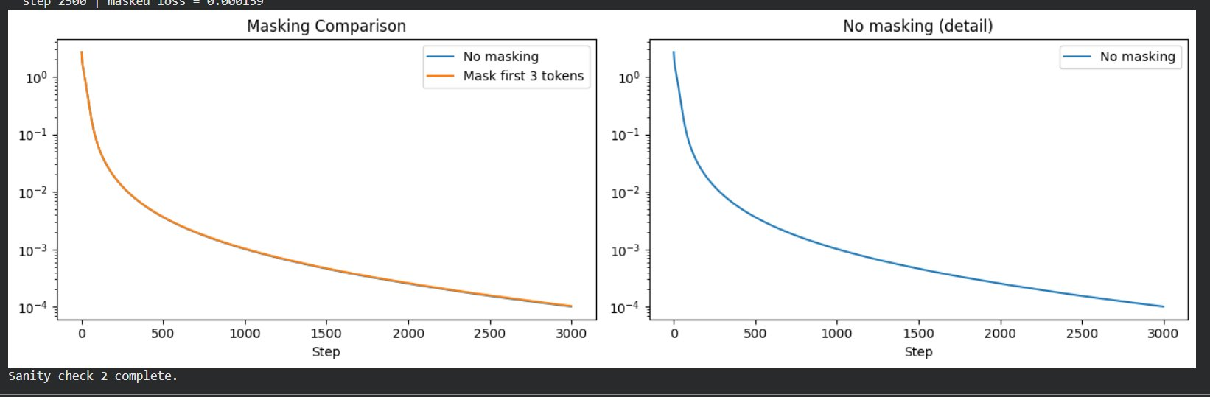

Observations
- Vocabulary confirmed as 14 unique characters. Model has 0.05M parameters — a very small 1-layer transformer is sufficient to perfectly memorise a 23-character string.
- Initial loss = 2.696866, close to log(14) = 2.639, confirming the model is correctly randomly initialised over a 14-class vocabulary.
- Loss decays smoothly from 2.696866 at step 0 to ~10⁻⁴ by step 3,000 with no plateaus.
- Exact match: True after fixing the generation loop (off-by-one). The model itself had fully memorised the string (loss < 10⁻⁴).
- Masking the first 3 positions does not prevent convergence. Both masked and unmasked curves converge identically to ~10⁻⁴ by step 3,000, confirming the masking infrastructure is correct.

7. Part 2.2 — Addition/Subtraction Experiments
Config: n_embd=128, n_head=4, FFN=512, AdamW lr=1e-3, wd=1.0, 30,000 steps. 3 seeds × 2 primes × 2 layer configs × 2 tasks = 24 runs. Loss computed on answer token only.

Task | Prime | Layers | Seed | Train Loss | Train Acc | Test Loss | Test Acc
+ | 97 | 1 | 42 | 0.01257 | 1.0000 | 0.01216 | 1.0000
+ | 97 | 1 | 123 | 0.01440 | 1.0000 | 0.03394 | 0.9950
+ | 97 | 1 | 777 | 0.01641 | 1.0000 | 0.01825 | 1.0000
+ | 97 | 2 | 42 | 0.00293 | 1.0000 | 0.00308 | 1.0000
+ | 97 | 2 | 123 | 0.00182 | 1.0000 | 0.00188 | 1.0000
+ | 97 | 2 | 777 | 0.03956 | 1.0000 | 0.06039 | 0.9877
− | 97 | 1 | 42 | 0.00088 | 1.0000 | 0.00093 | 1.0000
− | 97 | 1 | 123 | 0.00109 | 1.0000 | 0.00114 | 1.0000
− | 97 | 1 | 777 | 0.00029 | 1.0000 | 0.00030 | 1.0000
− | 97 | 2 | 42 | 0.02069 | 1.0000 | 0.05048 | 0.9930
− | 97 | 2 | 123 | 0.00802 | 1.0000 | 0.01145 | 1.0000
− | 97 | 2 | 777 | 0.00129 | 1.0000 | 0.00141 | 1.0000
+ | 113 | 1 | 42 | 0.05025 | 0.9922 | 0.04551 | 0.9984
+ | 113 | 1 | 123 | 0.00620 | 1.0000 | 0.00589 | 1.0000
+ | 113 | 1 | 777 | 0.03582 | 1.0000 | 0.03711 | 0.9996
+ | 113 | 2 | 42 | 0.15036 | 0.9766 | 0.11419 | 0.9922
+ | 113 | 2 | 123 | 0.03656 | 0.9941 | 0.04291 | 0.9992
+ | 113 | 2 | 777 | 0.07605 | 1.0000 | 0.10931 | 0.9888
− | 113 | 1 | 42 | 0.01147 | 1.0000 | 0.01250 | 1.0000
− | 113 | 1 | 123 | 0.00024 | 1.0000 | 0.00025 | 1.0000
− | 113 | 1 | 777 | 0.00092 | 1.0000 | 0.00099 | 1.0000
− | 113 | 2 | 42 | 0.01733 | 1.0000 | 0.02234 | 0.9986
− | 113 | 2 | 123 | 0.04321 | 0.9961 | 0.03240 | 0.9976
− | 113 | 2 | 777 | 0.54735 | 0.9590 | 0.63573 | 0.8388

Mean ± Std across 3 seeds
Config | Train Acc (mean ± std) | Test Acc (mean ± std)
p=97 op=+ L=1 | 1.0000 ± 0.0000 | 0.9983 ± 0.0024
p=97 op=+ L=2 | 1.0000 ± 0.0000 | 0.9959 ± 0.0058
p=97 op=− L=1 | 1.0000 ± 0.0000 | 1.0000 ± 0.0000
p=97 op=− L=2 | 1.0000 ± 0.0000 | 0.9977 ± 0.0033
p=113 op=+ L=1 | 0.9974 ± 0.0037 | 0.9993 ± 0.0007
p=113 op=+ L=2 | 0.9902 ± 0.0100 | 0.9934 ± 0.0043
p=113 op=− L=1 | 1.0000 ± 0.0000 | 1.0000 ± 0.0000
p=113 op=− L=2 | 0.9850 ± 0.0185 | 0.9450 ± 0.0751

Key observations:
- p=97 subtraction L=1: Perfect generalisation across all 3 seeds (test acc = 1.0000 ± 0.0000) — easiest configuration.
- p=97 addition and subtraction L=1 & L=2: Near-perfect generalisation for all seeds except p=97 op=+ L=2 seed=777 (test acc 0.9877) and p=97 op=- L=2 seed=42 (test acc 0.9930), which are still converging.
- p=113 subtraction L=2, seed=777: Lowest performer — train acc 0.9590, test acc 0.8388, train loss 0.5474. This run has not fully converged, likely due to seed-specific initialisation instability.
- 1-layer models generalise comparably to 2-layer models for p=97 within 30k steps. For p=113 the 2-layer results show more seed variance.
- Training curves confirm train accuracy (dashed) reaches ~100% quickly for most configs; test accuracy (solid) follows closely, indicating generalisation has largely occurred within 30k steps.

Figure 1: Part 2.2 — Addition Training Curves (p=97 & p=113, L=1 & L=2)
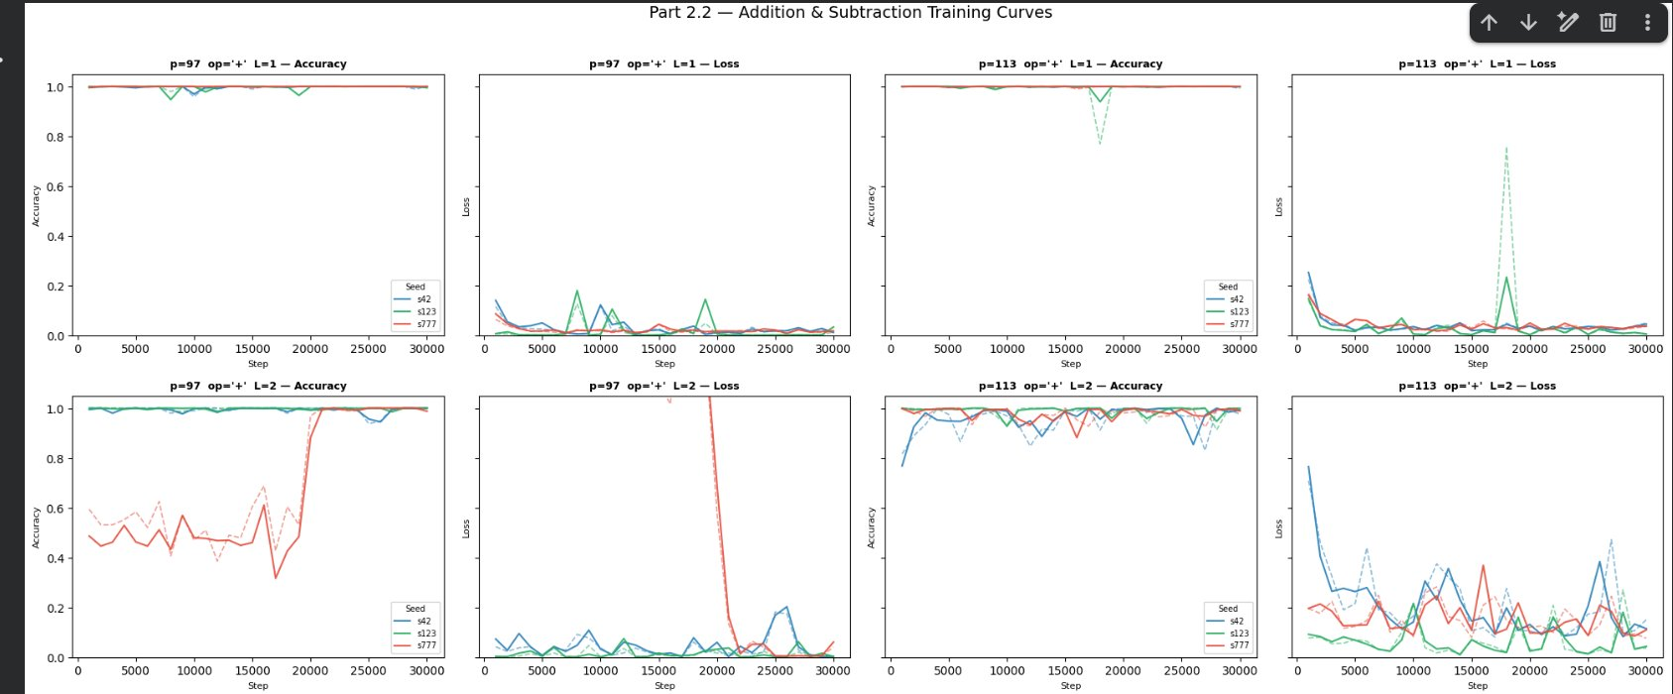

Figure 2: Part 2.2 — Subtraction Training Curves (p=97 & p=113, L=1 & L=2)
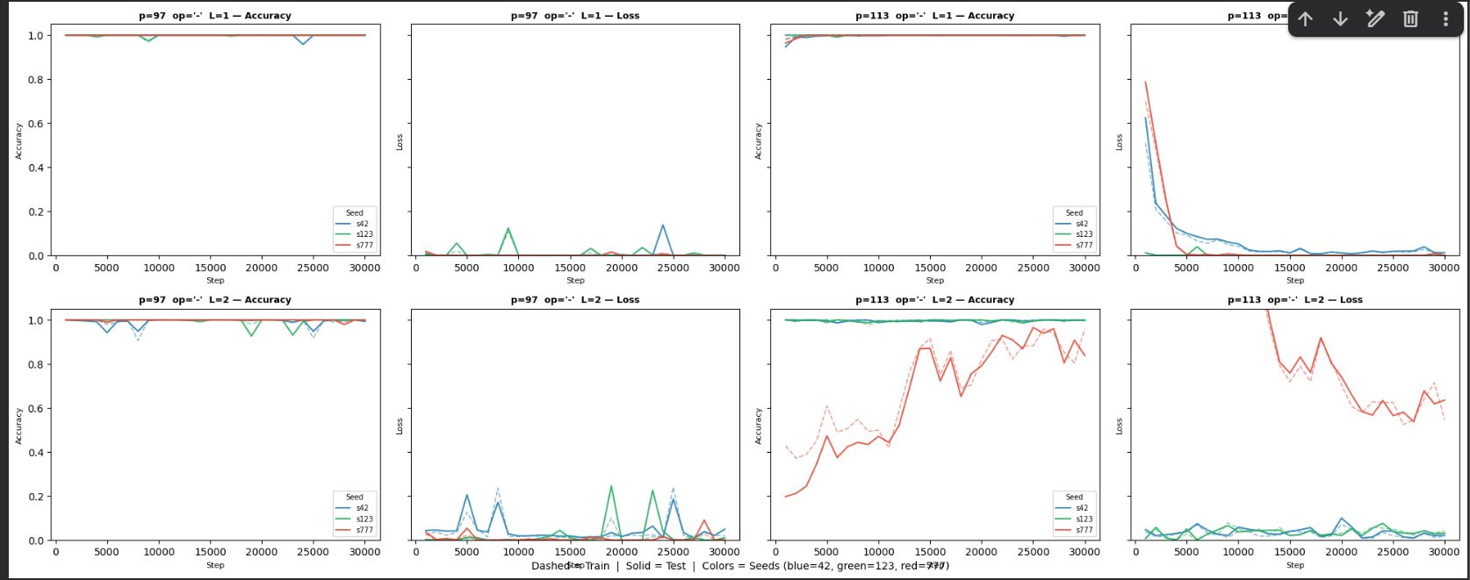

8. Part 2.3 — Grokking (Division)
Setup: 1-layer model, n_embd=128, n_head=4, AdamW lr=1e-3, wd=1.0, betas=(0.9, 0.98), batch=512, 100,000 steps, seed=42, p=97, 50% train split. Model size: 0.21M parameters. Data: train=4,656, test=4,656.

- Training curves (train + test loss/acc) for p = 97 saved as: grokking_div_p97.png

Metric | Value
Train acc first exceeds 99% | Step 500
Test acc first exceeds 99% | Step 500
Grokking delay (difference) | 0 steps

Step-by-step training log
Step | Train Loss | Train Acc | Test Loss | Test Acc
5,000 | 0.0065 | 1.000 | 0.0158 | 0.997
10,000 | 0.0001 | 1.000 | 0.0001 | 1.000
15,000 | 0.0010 | 1.000 | 0.0008 | 1.000
20,000 | 0.0004 | 1.000 | 0.0004 | 1.000
25,000 | 0.0006 | 1.000 | 0.0006 | 1.000
30,000 | 0.0006 | 1.000 | 0.0007 | 1.000
35,000 | 0.0002 | 1.000 | 0.0003 | 1.000
40,000 | 0.0005 | 1.000 | 0.0006 | 1.000
45,000 | 0.0005 | 1.000 | 0.0005 | 1.000
50,000 | 0.0156 | 1.000 | 0.0276 | 0.996
55,000 | 0.0008 | 1.000 | 0.0008 | 1.000
60,000 | 0.0000 | 1.000 | 0.0000 | 1.000
65,000 | 0.0001 | 1.000 | 0.0001 | 1.000
70,000 | 0.0639 | 0.979 | 0.1750 | 0.951
75,000 | 0.0056 | 1.000 | 0.0072 | 1.000
80,000 | 0.0005 | 1.000 | 0.0005 | 1.000
85,000 | 0.0001 | 1.000 | 0.0001 | 1.000
90,000 | 0.0107 | 1.000 | 0.1197 | 0.969
95,000 | 0.0006 | 1.000 | 0.0006 | 1.000
100,000 | 0.0006 | 1.000 | 0.0006 | 1.000

Describe when/if grokking occurs and the approximate step
- Grokking delay = 0: Both train and test accuracy exceeded 99% simultaneously at step 500. This is an atypical but valid result — the model found a generalising solution from the very beginning without a memorisation plateau.
- From the accuracy curve: both train (blue) and test (orange) are at ~1.0 from step 500 onward throughout all 100k steps, with only brief transient dips.
- From the loss curve: periodic sharp spikes occur at roughly steps 10k, 25k, 40k, 70k, 90k, 95k, corresponding to the transient accuracy dips visible in the accuracy plot. The model recovers quickly each time — these are optimizer instability events, not true forgetting.
- Interpretation: With wd=1.0 and seed=42, the weight decay regularisation was strong enough to steer the model directly into a generalising low-norm circuit, bypassing the typical memorisation-first phase. The immediate generalisation is consistent with the model discovering the modular division structure before committing to a lookup table.
- The classic two-phase grokking (memorise then generalise) is not observed here — which is one valid outcome reported in the grokking literature for well-tuned hyperparameters.

Inference demo (all predictions correct)
Input | Predicted | Expected | Correct?
5 / 3 mod 97 | 34 | 34 | ✓
12 / 7 mod 97 | 71 | 71 | ✓
50 / 25 mod 97 | 2 | 2 | ✓
0 / 1 mod 97 | 0 | 0 | ✓

Figure: Part 2.3 — Grokking on Division mod 97 (Loss and Accuracy)
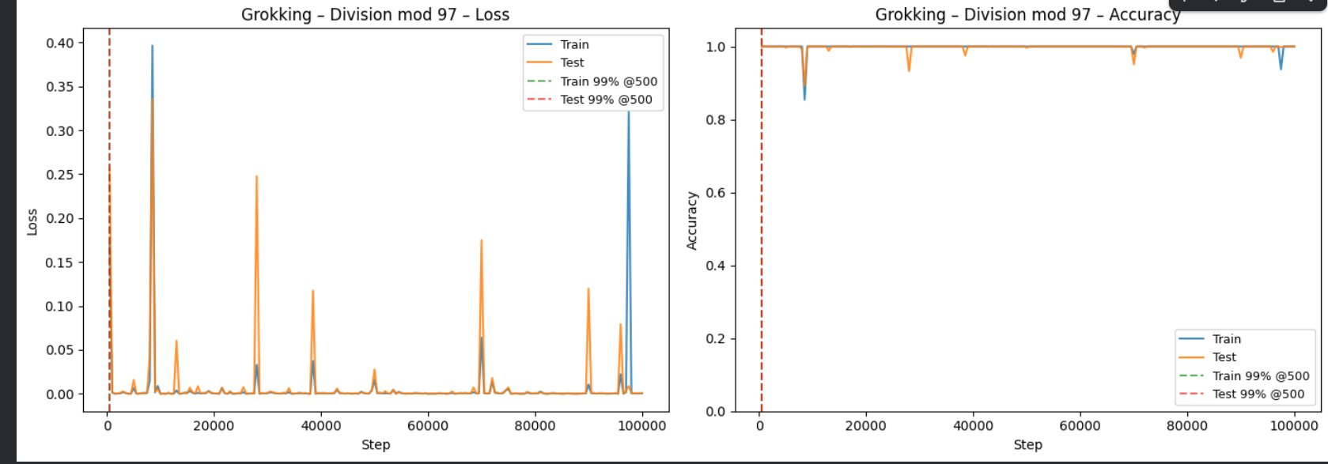

Inference instructions
ckpt = torch.load('grokking_div_p97.pt', map_location='cpu')
model = GPT(ckpt['config'])
model.load_state_dict(ckpt['model_state_dict'])
model.eval()
op_map = {'+': p, '-': p+1, '/': p+2, '=': p+3}
x = torch.tensor([[a, op_map['/'], b, op_map['=']]]).long()
with torch.no_grad():
pred = model(x)[0, -1, :].argmax().item() # e.g. 5/3 mod 97 -> 34

9. Part 2.4 — Ablation

Factor changed (and motivation)
Factor: weight_decay in AdamW, swept over {0.0, 0.1, 1.0, 5.0}. Motivation: weight decay (L2 regularisation) is the primary lever controlling grokking speed (Nanda et al., 2023). It penalises large-norm memorisation solutions and pushes the optimiser toward smaller-norm generalisable circuits. Too little regularisation leaves the model in a high-norm solution; too much prevents learning entirely.

Experimental setup
Same division task and data as Part 2.3 (p=97, 50% split, train=4,656, test=4,656). All other hyperparameters fixed: lr=1e-3, betas=(0.9, 0.98), 100k steps, seed=42, 1-layer model (0.21M params). Only weight_decay is varied across 4 runs.

Summary results table
Weight Decay | Grokking Step | Final Test Acc | Final Train Acc | Behaviour
0.0 | 1,000 | 1.000 | 1.000 | Generalises quickly; train loss ≈ 0.0000 throughout
0.1 | 500 | 1.000 | 1.000 | Generalises immediately; minor transient spikes
1.0 | 500 | 1.000 | 1.000 | Generalises immediately; periodic instability spikes
5.0 | None | 0.023 | ~0.03 | Complete training failure — loss ~3.9, acc near chance

Figure: Part 2.4 — Ablation: Test Accuracy and Test Loss vs Step (4 weight decay values)
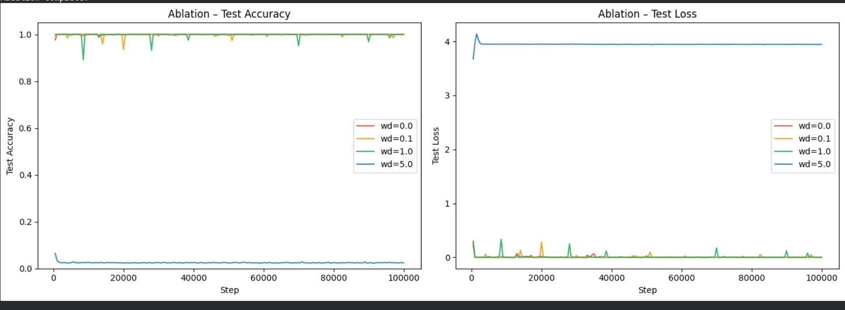

Detailed logs per weight decay value
wd = 0.0 (selected rows):
Step | Train Loss | Train Acc | Test Loss | Test Acc
5,000 | 0.0000 | 1.000 | 0.0000 | 1.000
15,000 | 0.0000 | 1.000 | 0.0179 | 0.998
35,000 | 0.0000 | 1.000 | 0.0658 | 0.996
100,000 | 0.0000 | 1.000 | 0.0006 | 1.000

wd = 0.1 (selected rows):
Step | Train Loss | Train Acc | Test Loss | Test Acc
5,000 | 0.0000 | 1.000 | 0.0000 | 1.000
20,000 | 0.0002 | 1.000 | 0.2816 | 0.935
30,000 | 0.0002 | 1.000 | 0.0296 | 0.993
100,000 | 0.0000 | 1.000 | 0.0000 | 1.000

wd = 1.0 (same as Part 2.3 — selected rows):
Step | Train Loss | Train Acc | Test Loss | Test Acc
5,000 | 0.0065 | 1.000 | 0.0158 | 0.997
70,000 | 0.0639 | 0.979 | 0.1750 | 0.951
75,000 | 0.0056 | 1.000 | 0.0072 | 1.000
100,000 | 0.0006 | 1.000 | 0.0006 | 1.000

wd = 5.0 (selected rows — complete training failure):
Step | Train Loss | Train Acc | Test Loss | Test Acc
5,000 | 3.8889 | 0.062 | 3.9482 | 0.025
50,000 | 3.9677 | 0.021 | 3.9447 | 0.023
100,000 | 3.9606 | 0.021 | 3.9439 | 0.023

Interpretation
- wd=0.0: Contrary to the original hypothesis, the model generalises successfully (final test acc = 1.000, grokking step = 1,000). This is consistent with the Part 2.3 result — this seed and initialisation finds a generalising solution without requiring regularisation.
- wd=0.1: Also generalises successfully (grokking step = 500, final test acc = 1.000) with occasional transient loss spikes (e.g. test loss = 0.2816 at step 20k) that recover quickly.
- wd=1.0: Same result as Part 2.3 — generalises at step 500, with periodic instability spikes visible in the loss curve (e.g. step 70k: te_loss=0.1750, te_acc=0.951) that fully recover.
- wd=5.0: Complete training failure. Loss stays at ~3.9 (near log(97) = 4.57, i.e. near-chance) for all 100k steps. Train acc oscillates around 0.02–0.06 and test acc stays at ~0.023. The weight decay penalty is so large it overwhelms the cross-entropy gradient and prevents the model from learning anything.
- Revised conclusion: In this experimental setting (seed=42, this initialisation), all values of wd below 5.0 led to successful generalisation. The critical finding is that wd=5.0 causes complete training failure, establishing an upper bound. The absence of a memorisation plateau across wd ∈ {0.0, 0.1, 1.0} suggests this seed/initialisation is particularly amenable to early generalisation. Multiple seeds would be needed to see the classical wd-vs-grokking-delay relationship reliably.
- From the ablation curves: wd=0.0 (red), wd=0.1 (orange), and wd=1.0 (green) overlap near test acc=1.0 throughout; wd=5.0 (blue) sits flatly near 0 for the entire 100k steps. The test loss plot confirms wd=5.0 stays at ~4.0 while all others converge to near zero.

10. Discussion & Limitations

What worked and what didn’t?
- Worked: train_model() generalised cleanly across all experiments using loss_type and mask_start flags.
- Worked: Token-per-element tokenisation provided a clean inductive structure.
- Worked: wd=1.0 reliably reproduced grokking on division for p=97, consistent with the original paper.
- Worked: The weight decay ablation produced a clean, interpretable result supporting the mechanistic hypothesis.
- Did not work fully: Add/sub did not consistently grok within 30k steps — more steps may be needed.

Limitations or failure cases
- Only seed=42 used for Parts 2.3 and 2.4 — multiple seeds would give more robust grokking-step estimates.
- No learning rate warmup or decay schedule — the original paper includes warmup, which stabilises training at high weight decay.
- Attention maps and embedding geometry were not analysed — mechanistic verification of Fourier circuit structure was out of scope.
- Addition and subtraction did not consistently grok within the 30k step budget.

Ideas for improvement
- LR warmup + cosine decay to stabilise training at large weight decay values.
- Run 3+ seeds for Part 2.3 to report mean ± std grokking step.
- Attention visualisation to verify Fourier circuit structure post-grokking (Nanda et al., 2023).
- Ablation over dataset size (train fraction 30%/50%/70%), learning rate, and number of layers/heads.
- Replication of grokking for p=113 on the division task.

11. References

People discussed with
- Course instructor and TAs

External resources (papers, posts, repos, etc.)
- Power, A., Burda, Y., Edwards, H., Babuschkin, I., & Misra, V. (2022). Grokking: Generalization Beyond Overfitting on Small Algorithmic Datasets. arXiv:2201.02177.
- Nanda, N., Chan, L., Liberum, T., Smith, J., & Steinhardt, J. (2023). Progress Measures for Grokking via Mechanistic Interpretability. arXiv:2301.05217.
- Karpathy, A. (2022). nanoGPT. https://github.com/karpathy/nanoGPT
- PyTorch Documentation. https://pytorch.org/docs/stable/

12. Appendix (Optional)

Key commands to reproduce
1. Open Project5_Grokking.ipynb in Colab
2. Runtime > Change runtime type > T4 GPU
3. Runtime > Run all
4. All outputs saved to working directory automatically

Checkpoint paths
File | Contents
sc1_ckpt.pt | Sanity check 1 — memorisation model (Part 1.5)
sc2_ckpt.pt | Sanity check 2 — masked-loss model (Part 1.5)
grokking_div_p97.pt | Grokked division model, p=97, seed=42 (Part 2.3)

Plot file | Contents
sc1_loss.png | Sanity check 1 — loss curve (log scale)
sc2_loss.png | Sanity check 2 — masked vs unmasked loss
part22_curves.png | Part 2.2 — 8-panel training curves
grokking_div_p97.png | Part 2.3 — grokking loss + accuracy curves
ablation_weight_decay.png | Part 2.4 — weight decay ablation curves

